NYDF 2019 Goal 5 Assessment

Draft – 11 June 2019

**Goal 5: Restore 150 million hectares of degraded landscapes and forestlands by 2020 and significantly increase the rate of global restoration thereafter, which would restore at least an additional 200 million hectares by 2030**

Key Messages

* [placeholder]

## Overview of Goal and Indicators

The New York Declaration on Forests (NYDF) Goal 5 endorses and builds on the [Bonn Challenge,](http://www.bonnchallenge.org/content/challenge) a global initiative launched in 2011 with the goal of bringing 150 million hectares (mha) of the world’s deforested and degraded land into restoration by 2020. In 2014, the NYDF adopted the 150 mha goal and extended the ambition to restore an additional 200 mha by 2030. Together, these initiatives represent a ‘goal continuum’ of 350 mha by 2030.

Goal 5 of the NYDF and the Bonn Challenge are in line with and provide a means to deliver on other international commitments to increase forests, including UNFCCC REDD+ (“enhancement of forest carbon stocks”), UN CBD Aichi Target 15 ("By 2020… restoration of at least 15% of degraded ecosystems"), Sustainable Development Goals 6.6 and 15.2 (“By 2020, protect and restore water-related ecosystems, including mountains, forests, wetlands…,” and “By 2020…restore degraded forests and substantially increase afforestation and reforestation globally”), and for some countries, their nationally determined contributions (NDC) under the Paris Agreement. Ongoing efforts to monitor restoration in the context of these commitments rely on self-reported information from countries.[1]

Restoration has various interpretations due to the different types of degradation that it seeks to remedy, but also due to the different objectives of the land managers promoting restoration[2]. In 2000, a group of experts established the term “forest landscape restoration” (FLR) (sometimes referred to as “forest and landscape restoration”) to broaden the concept of forest restoration, and incorporate multiple objectives in landscape mosaics that include regaining ecological integrity (e.g., ecological structure and function including biodiversity, water provision, carbon sequestration and soil health) and enhancing human well-being (e.g. improved livelihoods, agriculture production and commercial opportunities, and increased resilience to climate change)[3]. In contrast to site-based ecological restoration where the focus is to recover forests back to their reference condition or the practice of reforestation or afforestation to create productive forests, the FLR approach encompasses a range of activities that balance environmental and socio-economic needs in landscapes so that restored forests can co-exist in a landscape mosaic with other land uses, thus providing benefits to people and to biodiversity[4],[5]. The Global Partnership on Forest and Landscape Restoration GPFLR defines FLR as "*a process that aims to regain ecological functionality and enhance human well-being in deforested or degraded landscapes. As a process, FLR is not an end in itself, but a means of regaining, improving, and maintaining vital ecological and social functions, in the long-term leading to more resilient and sustainable landscapes.*"[6] (**Box 1**).

The NYDF does not explicitly define restoration nor specifiy the types of activities that should be included in the 350 mha goal; however, given its similar objectives to the Bonn Challenge, which is based on implementation of FLR, we have focused our assessment of the NYDF on the interventions encompassed by the FLR approach. As such, we have outlined restoration activities according to established definitions for FLR (**Box 1)**.

**Box 1: Definitions**

**Forest (UNFCCC[7]): “**is a minimum area of land of 0.05-1.0 hectares with tree crown cover (or equivalent stocking level) of more than 10-30 percent with trees with the potential to reach a minimum height of 2-5 metres at maturity in situ. A forest may consist either of closed forest formations where trees of various storeys and undergrowth cover a high proportion of the ground or open forest.”

**Ecosystem services**

**Forest landscape restoration: “**the long-term process of regaining ecological functionality and enhancing human well-being across deforested or degraded forest landscapes”.[8] Degraded landscapes include forests and related landscapes and ecosystems that have lost their structure, function, biodiversity, or experienced other significant damage and overexploitation.[9]In this report, forest landscape restoration includes all tree-based interventions such as regeneration, reforestation and afforestation that result in an increase in tree cover and/or forest cover. Specific activities could include establishing natural or semi-natural forests, as well as improving existing landscapes with increased forest cover and/or trees such as plantations and agroforestry systems. Non-tree-based activities (e.g. soil restoration) are excluded. The included activities are defined as follows[10]:

1. **Establish natural or semi-natural forest:**   
   Natural regeneration involves allowing forest systems to spontaneously regrow without any tree planting or other assisted regeneration practices.   
   Assisted natural regeneration aims to accelerate natural regeneration and/or guide successional trajectories through activities that enhance tree growth, such as removing invasive grasses, liana cutting, and/or other practices. We also include enrichment planting and threat exclusion (e.g. fencing and fire control) in this category.   
   Active ecological restoration includes smaller tree configurations as well as large scale tree planting endeavours to restore native forests. Species may be mixed at the stand scale or in patches at the landscape scale. This strategy may also involve extensive natural regeneration following initial planting.
2. **Establish timber plantations**:   
   Mixed species plantations include at least two species intermixed on large areas in timbers stands and may involve a mix of native and non-native species, as well as even-aged or uneven-aged stands.  
   Monoculture plantations include plantation forests where the same species is grown on large areas, usually in even-aged stands.
3. **Develop agroforestry system**:   
   Intensive tree monocrops include all non-timber monocultures, such as fruit or nut tree monocultures, and other commodity crops.   
   Multistrata systems are those with a mix of under- and overstory species, and include home gardens and shade-grown cropping systems like cacao and coffee combined with shade-, timber- or commercial tree crops.   
   Tree intercropping includes agricultural systems where woody species are grown in crop fields, in scattered or systematic arrangements amongst annual crops or herbaceous perennials.Silvopastoral systems include grazing land with scattered or planted trees, as well as tree-fodder systems.
4. **Incorporate transitional land use:** a strategy that involves incorporating a range of agroforestry and/or plantation approaches in early stages of reforestation, as a transitional phase towards native forest restoration, to overcome socioeconomic and ecological obstacles to restoring these lands

**Reforestation (UNFCCC[11]):** “is the direct human-induced conversion of non-forested land to forested land through planting, seeding and/or the human-induced promotion of natural seed sources, on land that was forested but that has been converted to non-forested land.”

**Afforestation (UNFCCC[12]):** “is the direct human-induced conversion of land that has not been forested for a period of at least 50 years to forested land through planting, seeding and/or the human-induced promotion of natural seed sources.” Note: many in the scientific community refer to afforestation as the process of foresting natural non-forest ecosystems such as natural grasslands, and thus may have a negative connotation. Restoring land that has not been forested for longer than 50 years, but was originally a forest, could therefore be referred to as reforestation in much of the literature.

**Tree cover gain: “**Tree cover” is defined as vegetation greater than 5 meters in height, and may take the form of natural forests or plantations across a range of canopy densities. “Gain” is defined as an increase in tree canopy cover or tree canopy height at the Landsat pixel scale . “Tree cover gain” may indicate a number of potential activities, including natural forest growth or the crop rotation cycle of tree plantations.

In the context of the NYDF, Goal 5 will be achieved when 350 mha of tree cover gain in forest landscapes have been successfully established through FLR activities. We acknowledge that FLR is more than just increasing tree cover, and we stress the importance of monitoring ecosystem function, ecosystem services and socio-economic outcomes in the context of FLR. However, at present, there are no adequate global data sets available to measure progress on forest landscape restoration beyond the biophysical increase in forest and/or tree cover. Estimates of progress on FLR has been reported by the Bonn Challenge Barometer in 2018 and 2019[13], yet only a small subset of pledgers is accounted for. Therefore, for the purposes of this report the “area under restoration” is defined as the area receiving the restoration intervention(s) and “restoration” is defined as an increase in forest and/or tree cover.

While global data on tree cover gain has been publicly available since 2015, it cannot be used to infer FLR because… Globally-comprehensive satellite-based data for monitoring restoration progress are difficult to produce and are still being developed. Unlike deforestation, which is a rapid and highly visible land cover change from space, forest regrowth is a more gradual process requiring monitoring over longer time horizons (**Box 2**). Forest regeneration and restoration are long-term processes that can span 20-200 years.[14] Further, restoration often involves small or dispersed patches of trees and shrubs within a mosaic landscape, or increasing density of trees, requiring higher resolution (and higher cost) satellite imagery to discern compared to typical deforestation monitoring systems. Currently, there are three satellite-based data sets that provide the best-available resource for monitoring biophysical progress on restoration: Collect Earth, University of Maryland GLAD tree cover gain, and Trends.Earth (**Box 3**). These three data sets…

**Box 2: How is monitoring restoration different from monitoring deforestation?**

Many countries and organizations have years of experience in measuring and monitoring deforestation as part of Reduced Emissions from Deforestation and forest Degradation and the role of conservation, sustainable management of forests and enhancement of forest carbon stocks in developing countries (REDD+) that is part of the Paris Agreement under the United Nations Framework Convention on Climate Change (UNFCCC) and other initiatives like the FAO Forest Resource Assessment (FAO FRA). Many of the same techniques used in monitoring deforestation can inform monitoring forest restoration, including satellite remote sensing, inventories, national statistics, and community-based surveys. However, there are important differences with regard to time and resolution that need to be considered for monitoring restoration.

**Time:** While deforestation is a near-instantaneous event and wider landscape degradation often takes place at a relatively fast rate, restoration typically occurs over much longer time spans on the order of years or decades. Measuring progress from seedlings to saplings and from young trees to mature trees requires a monitoring system that is based on a long-term time horizon. Therefore, it is important to determine what can be detected within the proposed timeframe. A monitoring framework based on the simple presence or absence of trees—which works for deforestation monitoring—does not capture the nuances of measuring progress on restoration.

**Resolution:** Deforestation often occurs over relatively wide swaths of dramatic change in land cover. Restoration, on the other hand, often widely varies in the extent of the application. Most often it occurs over smaller, more dispersed plots, such as with small-scale actors planting trees dispersed over a few hectares of their land. But in aggregate it can range from a few hectares to hundreds or even thousands of hectares. In either case, these restored areas are often characterized by dispersed widely spaced trees that do not form a uniform block. As a result, high- to very high-resolution satellite images need to be used to detect these small, dispersed, and subtle changes in the landscape and then measure overall change. Since higher resolution imagery covers a smaller total area per image, tens of thousands of images are usually needed to cover even a modest monitoring area. This means monitoring restoration needs to consider cost, volume of data, and time.

In the absence of a global dataset to monitor and measure forest landscape restoration, this report pulls together the best-available data for assessing progress on NYDF Goal 5. We developed an assessment framework with two overaching criteria (**Table 1**):

1. Rate of forest landscape restoration (hectares established over time), and
2. Forest landscape restoration efforts (political and socio-economic advancements).

The first criterion, rate of forest landscape restoration, provides a global overview of biophysical restoration progress. It includes two indicators, i) global area under FLR through a systematic literature review of peer reviewed studies as well as publicly available grey literature and databases and ii) area of tree cover gain in various regions derived using Earth Observation data from: Collect Earth, University of Maryland’s Global Land Analysis & Discovery (GLAD) tree cover gain, and Trends.Earth.

Given the current lack of global datasets that can satisfactorily monitor restoration, the second criterion, forest landscape restoration efforts, was established to serve as a proxy for tracking early developments toward restoration and showing directional trends. Adapted from the Bonn Challenge Barometer, this criterion outlines and reports on three indicators related to key political and socio-economic conditions necessary to catalyse restoration: i) high-level pledges, ii) planning and implementation steps, and iii) financing. The assessment framework will be updated as data improves and becomes available.

The framework assessment for Goal 5 draws on and complements indicators from the Bonn Challenge Barometer[15]. The Barometer, developed through a participatory stakeholder process in five countries and launched in 2017, collects information from each pledger (national or subnational government) to track progress toward achieving the Bonn Challenge Commitments.[16] The Barometer is structured into two overarching set of indicators: “success factors”, or policies and institutional frameworks, financial flows and technical planning that create the enabling conditions needed for FLR implementation and “results and benefits” which include the results of FLR actions in terms of the land area brought into restoration (in hectares), and the climate mitigation, biodiversity conservation and job creation benefits associated with them. As of 2019, there are in-depth reports from five countries and rapid assessments from 14 countries. Data from the “results and benefits” for the five pilot countries on the land area brought into restoration was incorporated into the systematic literature review (indicator 1.1). Information from the “success factors” was incorporated into Indicators 2.1, 2.2 and 2.3.

**Table 1** Assessment Framework for NYDF Goal 5

|  |  |  |  |
| --- | --- | --- | --- |
| CRITERIA | INDICATORS | DATA SOURCES |  |
| **1. Rate of forest landscape restoration (hectares established over time)** | 1.1 Area under restoration (ha)  1.2 Tree cover gain (ha) | 1.1.1 Literature review  1.2.1 Collect Earth  1.2.2 Trends.Earth  1.2.3 Hansen Map |  |
| **2. Forest landscape restoration efforts (political and socio-economic advancements)** | 2.1 High-level pledges  2.2 Planning and implementation steps  2.3 Finance for FLR activities | 2.1.1 Bonn Challenge Barometer  2.1.2 NDCs  2.2.1 Bonn Challenge Barometer  2.2.2. Literature review  2.2.1 Bonn Challenge Barometer  2.3.1 Literature review |  |

**Criterion 1: Rate of forest landscape restoration**

Indicator 1.1: Area under restoration (ha)

For this indicator, a global, systematic literature review was conducted by researchers at the University of Virginia to assess available studies on forest landscape restoration activities and provide a bottom-up picture of progress. Peer reviewed literature, as well as publicly available reports and databases were assessed to build a comprehensive database of areas where forests were restored since 2000, since 2011 (start of the Bonn Challenge) and since 2014 (signing of the NYDF).

The primary literature review was conducted using Web of Science, and evaluated 3,654 total papers[17]. Grey literature and publicly available databases were also reviewed per expert recommendations and included reports and data from the Bonn Challenge Barometer[18], the Restoration Database for Latin America and the Caribbean from the CIAT/WUR project for USAID[19], and the GEF database[20]. The study used the UNFCCC definition of forest (**Box 2**); however, papers that identified the study system as forest but did not provide a formal, canopy-cover based definition were included. Of the papers and data sources assessed, only restoration activities that increase forest cover (activities defined in **Box 2**) since 2000 in the implementation/ongoing or completed phase were considered. Activities that did not provide an additional increase in forest cover such as forest management or silviculture of existing forests or plantations, good agriculture practices, restoration of soils, restoration of non-forest landscapes (e.g. grasslands and rangelands) and conservation (avoided deforestation) were excluded. Papers were also excluded where trees added were likely short-term, such as unassisted regeneration in existing forests following repeated disturbances (e.g. fire and windthrow), or timber rotation (e.g. harvest and replantings). Afforestation of non-forest landscapes were included. To focus on landscape-scale restoration, papers were excluded that reported forest cover increases of areas less than 100 ha, except for mangrove restoration which tends to be smaller scale. Plot-based studies in which the total restored area exceeded 100 ha were included, even if individual plots were <100 ha. Studies in which no new area of forest cover was added after 2000 were excluded. For studies in which restoration began prior to 2000 but additional area of forest cover was added after 2000, only forest area restored after 2000 were included in the analysis. For studies that reported increasing forest area from a timepoint before 2000 and a timepoint after 2000, linear expansion rates were assumed and included only the area restored after 2000 based on the linear extrapolation. Finally, for those papers that reported both restoration and degradation within the study area, gross restoration was included and not net restoration. Using these criteria, a total of 101 primary literature papers were included and 142 data entries from grey literature and public databases were included for analysis for a total of 243 data entries.

With the compiled data, each of the restoration locations per data entry were assessed to identify and remove duplicate initiatives and avoid double counting. In cases of duplicate estimates on the same area and time period, primary data were prioritized, and when both were primary, then the more recent or conservative estimate was included. After double counting, a total of 196 data entries remained. A meta-analysis was then conducted to determine the number of hectares restored by region, restoration type, ecosystem type and motive for restoration in the periods 2000-2011, 2011-2014, and 2014-2019.

The literature review findings indicate that we are not on track to meet the goal of restoring 150 mha of forest landscapes by 2020. Since 2000, approximately 26.7 million hectares (mha) of forest landscapes have undergone restoration (20.5 mha reforestation, 6.2mha afforestation), yet only 3.1 mha are under restoration (2.4 mha reforestation, 0.7 mha afforestation) since 2011 (start of the Bonn Challenge) and 235,700 ha (all reforestation) since 2014 (signing of the NYDF) (**Figure 1**). After the launch of the Bonn Challenge and NYDF, only ~2% of commitments to restore forests have been implemented, and the rate of forest landscape restoration decreased from approximately 2 mha/year between 2000-2010, to less than 1 mha/year after 2011. While most restoration (88%) occurred in the early 2000s (23.6 mha between 2000-2010), it is expected that primary literature data will be skewed given that more time has passed to produce studies. The more recent grey literature is also biased since only a small group of regions and countries were included in the various databases and reports. A lack of contemporary studies is a major limitation with this analysis. Furthermore, it is important to note that there is a lot of restoration that happens organically (e.g. in small areas driven by individuals) that may not be captured by academic literature, government reporting or project databases. Therefore the results of the study likely underestimate or provide conservative estimates on progress. However, the literature review provides the only systematic global assessment of restoration progress to date.

**Figure 1**. Increase in forest area (mha) through forest landscape restoration, by region and time period. The red bars represent the three time periods since 2000, and the blue bars represent the entire 20 years since 2000.

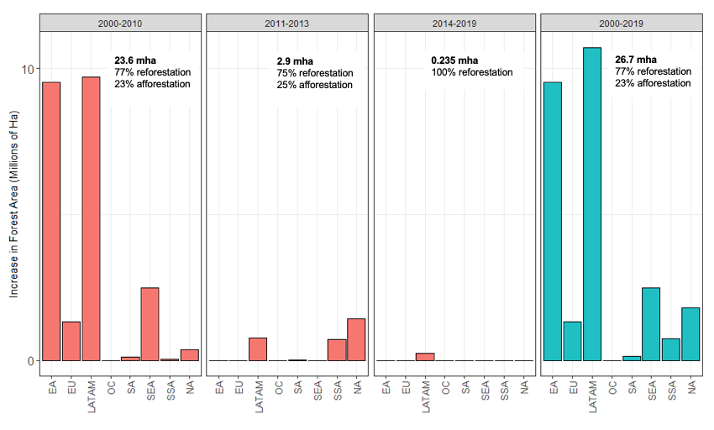

Regionally, Latin America and East Asia (China) represent the majority of areas under restoration. Between 2000-2010, 9.7 mha were under restoration (99.9 % reforestation) in Latin America, primarily as regeneration (97%) in Brazil. In China, 9.5 mha were under restoration, with approximately half (47%) occuring as afforestation with timber species. Southeast Asia and the EU also had significant restoration between 2000-2010 (2.5 mha and 1.3 mha respectively), primarily as timber plantations (66%) and regeneration (33%) in Vietnam and regeneration in Eastern Europe and Russia (75%). North America, South Asia, and Sub-Saharan Africa had moderate levels of restoration between 2000-2010 (0.4 mha, 0.13 mha and 0.04 mha respectively), mainly through regeneration and ecological restoration in the United States (90%), India (63%) and in West and East Africa (70%). From 2000-2010, the predominant motives for forest landscape restoration were risk mitigation (e.g. soil erosion, flooding) (13%), commercial interests and local employment (12% each), then enhancing soil fertility, carbon sequestration, ecosystem function, and water provision (8% each).

Since 2011 (start of the Bonn Challenge), a majority of the restoration occured in North America (USA) (1.4 mha), Latin America (0.75 mha), and Sub-Saharan Africa (0.70 mha). Since 2014, data was only available for Latin America (286,700 ha), with the majority of restoration undertaken in Brazil, Chile, Costa Rica, El Salvador, and Peru. Most restoration types since 2011 were active ecological restoration (24%), woodlots (unspecified kinds of timber plantations, 22%), natural and assisted regeneration (20%), agroforestry (16%), and afforestation (15%) (**Figure 2**). The primary motives for restoration post Bonn Challenge were recovering ecosystem function (18%), biodiversity (11%), local employment (11%), and carbon sequestration and risk mitigation (9% each).

**Figure 2**. Increase in forest area (mha) through forest landscape restoration, by restoration type. Number of ha per type of restoration are not exclusive and may overlap.

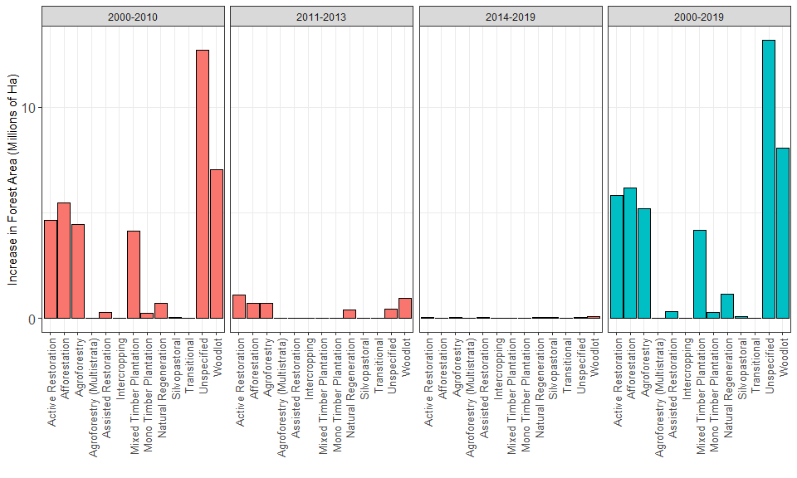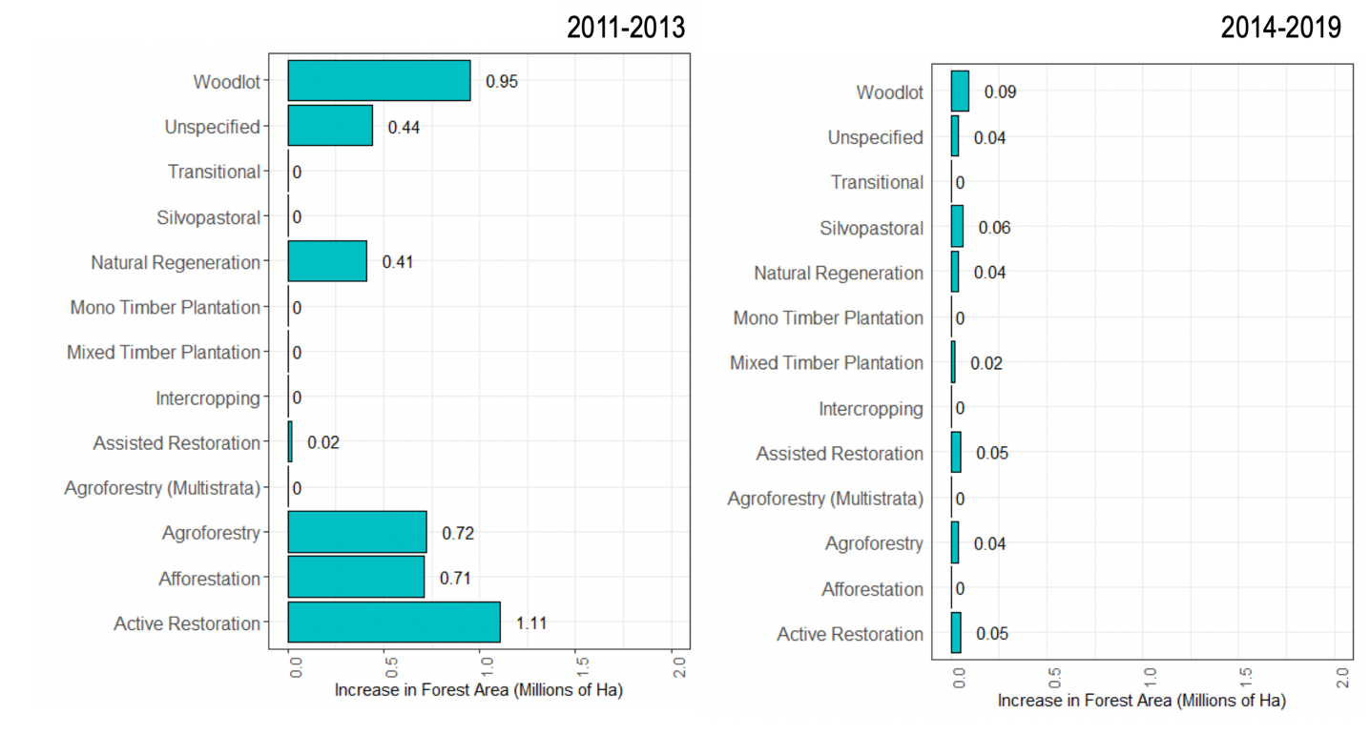

Since 2000, forest landscape restoration occurred primarily in tropical (40%) and temperate (18%) forest biomes. However, a significant portion (30%) also occurred in grasslands (tropical, temperate, montane and flooded), predominantly as afforestation. The large contribution of afforestation (mostly in Asian countries and Russia) to global restoration is of note (**Figure 3**). Globally, 6.16 mha was afforestated since 2000, with 4.46 mha (72%) of that reported in China and Mongolia. Most of this afforestation has occurred in grasslands (including montane as well as temperate grasslands) across both countries. Afforestation is defined by the UNFCCC as converting land that has not been forested for a period of >50 years to forested land, and therefore could include land that was a cropland for over 50 years yet was originally a forest ecosystem. However many in the scientific community refer to afforestation as the process of foresting non-forest ecosystems such as natural grasslands. In the literature, we included an activity as afforestation when it was explicitly defined as such, with most referring foresting non-forest ecosystems. Afforesting degraded grassland and other non-forest ecosystems with timber species does not restore the ecological complexity of the landscape, and further, may have negative ecological consequences. Add 2 sentences and citations on impact to soil, biodiversity, ecosystem function, and resource use of water and nutrients. Add 2-3 sentences on specific impact (positive and negative) in China/ Mongolia from the literature.

It should also be noted that anthropogenic climate change has potentially created new climate spaces for forests in regions of the globe—areas where forests can now grow where they could not previously due to biophysical limitations such as precipitation or temperature. The large contributions to overall restored area in regions such as grasslands and arid systems support this hypothesis. However, these new climate spaces are likely to be far more variable and less resilient than existing forests, meaning forests in these spaces are likely more vulnerable to climate perturbations and disturbances thus endangering any carbon offset gains.

**Figure 3**. Map of forest landscape restoration since 2000, disaggregated into afforestation and reforestation.

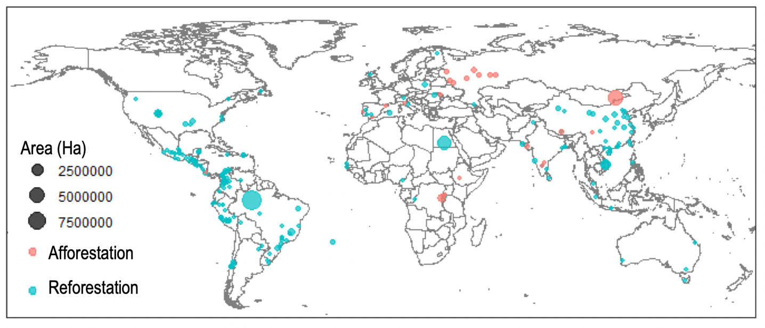

Indicator 1.2: Tree cover gain (ha)

The findings presented under this indicator highlight a systematic approach for monitoring the biophysical progress – specifically vegetation cover – around forest landscape restoration proposed by a team of researchers from the World Resources Institute, in consultation with the NYDF Assessment Partners and Goals 1 & 5 Expert Working Group. It draws on three methods and data outputs that are considered the best-available for monitoring biophysical progress on restoration: Collect Earth, University of Maryland GLAD tree cover gain, and Trends.Earth. While these datasets each have limitations, we demonstrate their complementarity in providing a comprehensive view of progress using the Mekong Region as a case study.

**Box 3: Tools for monitoring restoration**

Collect Earth –

Developed by the OpenForis initiative of the Food and Agriculture Organization of the United Nations (FAO), Collect Earth functions as a survey within Google Earth, accessing high-quality satellite images from various sources (high resolution, such as DigitalGlobe, as well as Landsat 7 and 8). It uses the human interpretation method for recording biophysical characteristics of a landscape using satellite imagery. The premise is that the human eye can more easily detect complex land cover types, such as agroforest (i.e., trees intermixed with cropland), that are difficult for spectral-interpretation algorithms to identify consistently. When biophysical measurements are recorded for two points in time, then a change assessment can be conducted. Three metrics are typically measured using Collect Earth and represent the best utilization of the program’s capabilities—percentage tree cover or vegetation cover, the number of trees, and the land-use type.

To achieve rapid results, Collect Earth “mapathons”-- organized sessions to collect biophysical data for specific landscapes in a group setting-- can collect a significant volume of data for an area of interest within a relatively short amount of time (on the order of days or weeks, depending on the size of the area and number of persons involved), and at relatively low cost. One of the advantages of using human interpretation via Collect Earth is that it can capitalize on the involvement of local communities, as these groups bring local knowledge from the landscape. Conversely, human interpretation by inexperienced data collectors can also lead to errors and uncertainties in the interpretation of features in the satellite images; however, interpretation made by local people along with in-field validation of an adequate percentage of the plots can help to minimize errors.

University of Maryland GLAD – To better estimate net tree cover change and gain dynamics over time, the University of Maryland’s Global Land Analysis and Discovery (GLAD) Lab recently developed a new algorithm to map annual tree canopy cover and height. The algorithm uses freely-available Landsat imagery and lidar-based vegetation structure prediction models (Potapov, et al. in press). A prototype dataset is currently available for the lower Mekong region, which includes annual data of both percent canopy cover and woody vegetation height in meters for the time period 2000 to 2017. From this data set, it is possible to identify areas that have experienced changes in canopy structure and composition over the past 18 years. The data are available for download (https://glad.umd.edu/) and online analysis (http://servir-rlcms.appspot.com/static/html/map.html) and serve as an input to the SERVIR-Mekong regional land cover monitoring system.

Trends.Earth – Trends.Earth is a free and open source tool developed by Conservation International for the assessment of land condition using Earth observation data to evaluate changes in primary productivity, land cover and soil organic carbon at varying spatial and temporal scales (Conservation International, 2018). The Productivity module in Trends.Earth was used to compute a land productivity trajectory analysis for the period 2001-2018. Trajectory measures the rate of change in primary productivity over time. Linear regressions at the pixel level are run on annual integrals of NDVI to identify areas experiencing changes in primary productivity for the period under analysis. A Mann-Kendall nonparametric significance test is then applied, considering only significant changes those that show a p-value ≤ 0.05 (Conservation International, 2018). Positive significant trends in annual integrals of NDVI would indicate increases in vegetation cover and biomass (Sims et al., 2017), and potentially improvements in land condition, such as those expected under restoration management. Significantly negative trends would indicate potential land degradation.

### Text on the role of bottom up monitoring to be added

Solely focusing on reporting output indicators may not provide insights into why or why not forest restoration interventions are effective or help to scale up efforts by identifying and solving management issues. These issues could occur across sites or across jurisdictional scales; for example, from on-the-ground initiatives to national reporting. Top down monitoring tools need to be complemented with those for gauging the effectiveness of a given restoration activity and its objectives in order to catalyze reflection, learning and multi-scalar thinking. Tools and approaches exist for implementing *participatory* monitoring which refers to a “continuum of engagement” from local people to professional researchers in the collection and use of information for decision-making, primarily at the local level (Evans and Guariguata 2016). And also for *collaborative* monitoring which likewise includes multiparty monitoring activities but also embraces cross-scale, multilevel actors and interactions that are networked to share information and influence change (Evans and Guariguata 2019).

### Setting a baseline for monitoring restoration

In 2016, the Food and Agriculture Organization of the United Nations (FAO) led a study that identified 467 million hectares of forest in dryland biomes that had not been previously reported, comprising a 9-percent increase in global forest cover estimates.[21] This study was conducted via a series of regional Collect Earth mapathons (**Box 3**), which generated a global database of nearly 500,000 sample points recording land use/land cover type, tree cover, tree count, and other variables using imagery for approximately the year 2014. While the data collection process was designed to focus on dryland biomes, the mapathons actually collected data for all biomes globally and the resultant database provides one of the few snapshots of the status of land use/land cover and tree cover worldwide, particularly for trees outside the forest. However, this database contains limited information on land use/land cover change from previous years and no information on tree cover change. As such, the data do not provide insight into changes in these statistics over time, which would indicate progress on restoration. Conversely, the data set a baseline for the year that the NYDF was implemented, and could be revisited in the future to identify progress on restoration.

The results indicate the significance of capturing data on trees outside the forest to provide a comprehensive picture of tree cover and restoration efforts, which include many areas that are not “traditional” forest cover (i.e., areas of land greater than 0.5 hectares, with trees higher than 5 m and canopy cover greater than 10 percent, by FAO definition), such as tree cover integrated with croplands and grasslands.[22]

These baseline data are shown in **Table 2**, summarized by major geographic region and the average percent tree cover per hectare for the six IPCC categories of land use/land cover. The results demonstrate that tree cover can be prevalent on land uses outside of forests. For example, in North America, tree cover on settlements averages more than 16 percent, and tree cover on croplands in Africa and Asia averages more than 6 percent.

***Table 2****. Average percent tree cover per hectare per land use type and geographic region, as aggregated from FAO’s Global Collect Earth database, 2014.*

|  |  |  |  |  |  |  |  |  |
| --- | --- | --- | --- | --- | --- | --- | --- | --- |
| **Region** | **No. sample plots** | **Average percent tree cover per hectare per land use type** | | | | | | **Avg pct tree cover - all land uses** |
| **Crop-land** | **Forest** | **Grass-land** | **Other**  **land** | **Settle-ment** | **Wet-land** |
| **Africa** | 122,667 | 6.0 | 57.8 | 4.1 | 0.1 | 7.1 | 1.7 | **19.1** |
| **Asia** | 110,373 | 6.1 | 76.3 | 2.1 | 0.0 | 12.1 | 1.0 | **20.6** |
| **Europe & Russia** | 74,257 | 4.6 | 70.1 | 2.6 | 0.4 | 12.8 | 1.3 | **36.1** |
| **North America** | 68,252 | 3.9 | 71.0 | 1.8 | 0.1 | 16.3 | 0.8 | **32.4** |
| **Oceania** | 21,767 | 2.9 | 56.2 | 1.8 | 0.1 | 10.4 | 1.9 | **18.9** |
| **South America** | 79,013 | 3.2 | 78.9 | 1.8 | 0.0 | 11.4 | 0.9 | **42.3** |
| **Total** | **476,329** | **5.2** | **70.2** | **2.6** | **0.1** | **12.4** | **1.2** | **27.8** |

Figure 1. Average percent tree cover by land use type and region.

### Changes in land productivity as a possible measure of restoration

Using data from Conservation International’s Trends.Earth tool, we aimed to identify recent changes in primary productivity which could potentially be linked to NYDF.increases in vegetation cover, or “greenness”. As such, we compared the overall long-term trends, 2000-2014, in primary productivity (2001-2018) to a short-term analysis for the period 2015-2018, using NDVI derived from MODIS satellite imagery. The map in Figure 2 shows the results of this analysis for Africa. The shades of green represent areas of recent increase in primary productivity in areas of either long-term decrease or long-term stability. While increases in primary productivity could be related to activities other than restoration (e.g., increased fertilizer application that increased crop production or increased rainfall), this analysis shows areas that indicate potential restoration activities to be be explored further.

Figure 2. Areas of recent increases in primary productivity, which could be indicative of restoration, using Trends.Earth

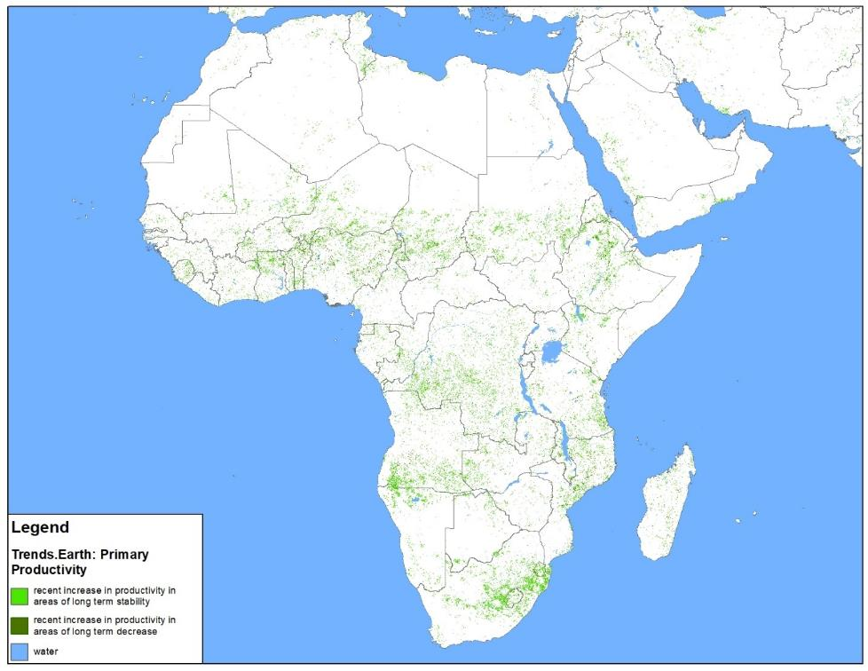

Toward a global dataset for restoration using existing tools: Mekong Region pilot

While there are currently no global datasets that can measure progress on forest landscape restoration, a suite of existing tools and methods could be utilized to create such a global dataset. To showcase this potential, we developed a pilot-scale analysis for the five countries of the Mekong region – Cambodia, Laos, Myanmar, Thailand, and Vietnam-- to report progress on NYDF Goal 5 and demonstrate how, given additional investment of resources, this analysis could be improved further and scaled up to a global restoration monitoring system. Two key tools and methods form the backbone of this pilot study and are specifically geared toward two separate forms of forest landscape restoration: trees inside the forest (i.e., relatively dense and clustered trees), and trees outside the forest (i.e., sparse tree cover on various land uses).

#### Trees Inside the Forest: GLAD Tree Cover and Height Dynamics

The University of Maryland GLAD lab’s dataset of tree canopy cover and height dynamics was used to identify progress on trees inside the forest. To inform progress on restoration in the region, we compared the most recent annual data (2017) with a baseline that represents the average tree canopy cover and tree canopy height from 2000 to 2010. These two time periods were chosen because: 1) forest change can happen relatively slowly and the period from 2011 to 2017 represent enough time to allow for significant changes to be detected by remote sensing; and 2) the Bonn Challenge, a major international forest landscape restoration initiative with similar goals to the NYDF, was launched in 2011; thus, the latter period represents a time where greater awareness and ambition toward restoration was initiated.[23] The baseline was set as an average of tree canopy cover and height for the period from 2000 to 2010, as opposed to any single year, to normalize for regular interannual fluctuations, such as from plantations.

To simplify and combine two complex datasets representing tree canopy cover and tree canopy height, we categorized the data to be representative of either restoration or degradation. We defined restoration as an increase in tree canopy cover of greater than 20% and any increase in tree cover height of greater than 5 meters using a pixel-by-pixel comparison of data for the baseline (2000-2010) and 2017. We defined degradation as the converse -- loss of tree canopy cover greater than 20% and loss of tree height greater than 5 meters.

The significance of this dataset is that it provides a comprehensive picture of forest cover change for the region – both the gain and loss. Therefore, it is possible to calculate the net impact of both restoration and forest degradation/deforestation on total forest cover. The results (Table 3) show that, in total for the Mekong region, there was both gain and loss of forest cover on the order of millions of hectares, with an overall net loss for both time periods of 7.8 million hectares, or a loss of roughly 2 percent of tree cover.

Analysis of the country-level results also show some interesting trends. Comparing the two time periods, Thailand was the only country in the region to have a net gain in tree cover, at 1.4M ha or a 2% increase in tree cover. Conversely, Laos had the highest net loss of tree cover compared to the country’s size – at 2.4 Mha and -9%, with Cambodia close behind at 2.5Mha and - 8%.

Overall the data show that forest cover change is a highly dynamic process – it cannot be viewed in terms of just deforestation or just restoration – it is the net change that is important. The data also show that forest cover change is spatially-explicit – it is highly variable from country to country– given that it is influenced by a multitude of factors.

***Table 3****. Estimated Net Change in Forest Cover in the Mekong Region: Comparing 2017 to the baseline period 2000-2010.*

|  |  |  |  |  |  |  |  |  |  |  |
| --- | --- | --- | --- | --- | --- | --- | --- | --- | --- | --- |
| **Country** | | **Loss (Mha)** | | **Gain (Mha)** | | | **Net change (Mha)** | | **Net change (%)** | |
| Cambodia | | 3.4 | | 1.4 | | | -2.0 | | -8% | |
| Laos | | 4.6 | | 2.1 | | | -2.4 | | -9% | |
| Myanmar | | 7.5 | | 5.1 | | | -2.5 | | -2% | |
| Thailand | | 3.7 | | 5.1 | | | +1.4 | | +2% | |
| Vietnam | | 5.8 | | 4.1 | | | -1.7 | | -2% | |
| **Mekong Region** | | 25.0 | | 17.8 | | | -7.2 | | -2% | |

The map in Figure 3 provides a more spatially-explicit visualization of the gain and loss of tree cover inside the forest, and in Figure 4, the data are summarized by province (or, in Myanmar, district). Any subnational area with a net change of +/- 2% tree cover was categorized as “increase” or “decrease”, respectively, while inside this range was categorized as “stable”. As shown in the map, every province in Laos has exceeded a 2% loss in tree cover, as has the majority of Cambodia, with the exception of the southeastern portion. Central and eastern Thailand demonstrates the most widespread net gain in tree cover. Provinces in southern Vietnam and several scattered districts in Myanmar also demonstrate net gain.

Figure 3. Extent of increase and decrease of trees inside the forest, 2010-2017

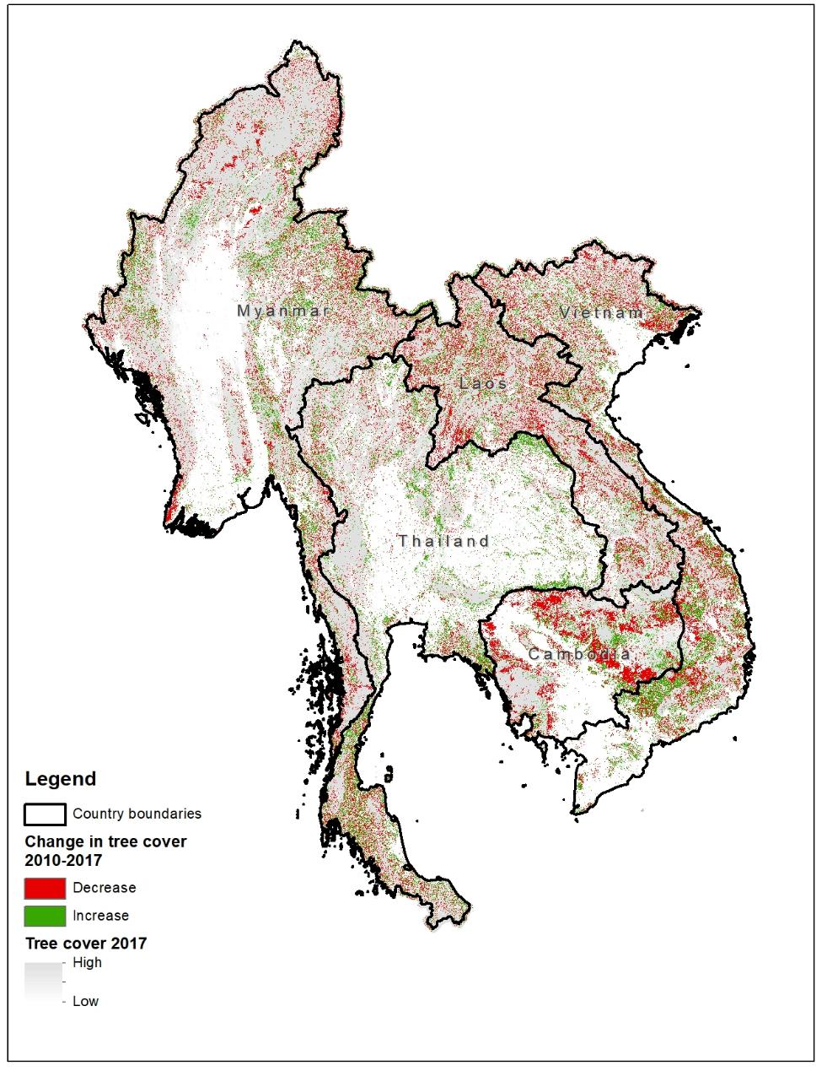

Figure 4. Summary of change in tree cover inside the forest by subnational jurisdiction.

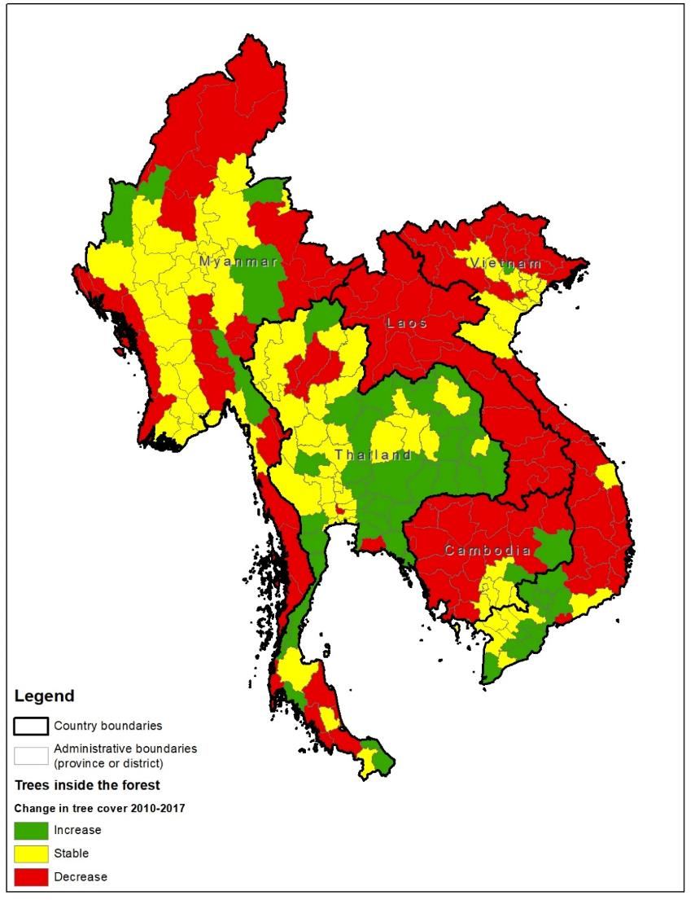

#### Trees Outside the Forest: Collect Earth

Collect Earth was used to measure tree cover that exists on multiple types of non-forest land uses and for varying densities of tree cover. As a tool, Collect Earth is suited for this type of data collection because it relies on very-high-resolution imagery and human interpretation, which can distinguish subtleties in tree cover and land use that are often undetected using algorithm-based remote sensing techniques.

For this pilot study, a Collect Earth mapathon was undertaken that collected data for more than 16,000 survey plots in the Mekong region. The plots spanned each of the five Mekong-region countries at equal intervals of either 10 or 12 km. The survey collected data on land use/land cover, tree count, and percent tree cover for three points in time: 2000, 2010, and 2018, so that change could be detected and quantified between these time periods to provide information on restoration progress. After analysing the collected data and aggregate sample set, there were not enough sample points with imagery available representing the year 2000 to provide statistically significant results; therefore, the analysis focused only on the data for years 2010 and 2018.

Similar to the results from the GLAD tree cover canopy and height dynamics data for trees inside the forest, among the Mekong region countries, both Cambodia and Laos demonstrated a decline in average tree cover on non-forest land use types, while Thailand, Myanmar, and Vietnam demonstrated an increase. Vietnam had the largest increase between the two time periods, with an increase in tree cover of 2.5% on non-forest land use types.

*Table 2. Comparison of average percent tree cover per hectare by country and land use type for two time periods: 2010 and 2018 based on Collect Earth surveys.*

|  |  |  |  |  |  |  |  |  |  |  |  |  |  |  |  |  |  |  |  |  |  |  |  |  |  |  |  |  |  |
| --- | --- | --- | --- | --- | --- | --- | --- | --- | --- | --- | --- | --- | --- | --- | --- | --- | --- | --- | --- | --- | --- | --- | --- | --- | --- | --- | --- | --- | --- |
|  | |  | | | | **2010** | | | |  | | | | | | | | **2018** | |  | | | | | | | | | |
| **Country and Land Use Type** |  |  | |  | | **Avg. % tree cover** | |  | | | | | |  | | | | **Avg. % tree cover** | | **Change from 2010** | | | | | | | | | |
| **Cambodia** | | | | | | **3.3** | | | | | | | | | | | | **2.8** | | **-** |  | | |  | | |  |  |  |
| Barren |  |  | |  | | 1.1 | |  | | | | | |  | | | | 0.7 | | - | | | | | | | | | |
| Bushland/Shrubland |  |  | |  | | 7.4 | |  | | | | | |  | | | | 7.8 | | + | | | | | | | | | |
| Cropland | | | |  | | 3.0 |  | | | | |  | | |  |  | | 3.5 | | + | | | | | | | | | |
| Grassland |  |  | |  | | 5.4 | |  | | | | | |  | | | | 6.0 | | + | | | | | | | | | |
| Settlement | | | | | | ND | | | | | | | | | | | | ND | |  |  | | |  | | |  |  |  |
| Wetland | | | |  | | 2.0 |  | | | | |  | | |  |  | | 1.6 | | - | | | | | | | | | |
| **Laos** | | | | | | **3.9** | | | | | | | | | | | | **2.4** | | **-** |  | | |  | | |  |  |  |
| Barren |  |  | |  | | 6.8 | |  | | | | | |  | | | | 5.5 | | - | | | | | | | | | |
| Bushland/Shrubland |  |  | |  | | 9.1 | |  | | | | | |  | | | | 8.7 | | - | | | | | | | | | |
| Cropland |  |  | |  | | 6.6 | |  | | | | | |  | | | | 5.9 | | - | | | | | | | | | |
| Grassland |  |  | |  | | 11.0 | |  | | | | | |  | | | | 14.6 | | + | | | | | | | | | |
| Settlement | | | |  | | ND | | |  | | | |  | | | | | ND | |  | | |  | | |  | | | |
| Wetland |  |  | |  | | 12.3 | |  | | | | | |  | | | | 3.8 | | - | | | | | | | | | |
| **Myanmar** | | | | | | **4.9** | | | | | | | | | | | | **5.0** | | **+** |  | | |  | | |  |  |  |
| Barren |  |  | |  | | 2.2 | |  | | | | | |  | | | | 1.8 | | - | | | | | | | | | |
| Bushland/Shrubland |  |  | |  | | 10.8 | |  | | | | | |  | | | | 15.2 | | + | | | | | | | | | |
| Cropland |  |  | |  | | 5.2 | |  | | | | | |  | | | | 5.5 | | + | | | | | | | | | |
| Grassland |  |  | |  | | 7.7 | |  | | | | | |  | | | | 9.1 | | + | | | | | | | | | |
| Settlement |  |  | |  | | 19.0 | |  | | | | | |  | | | | 22.0 | | + | | | | | | | | | |
| Wetland |  |  | |  | | 4.5 | |  | | | | | |  | | | | 6.1 | | + | | | | | | | | | |
| **Thailand** | | | | | | **7.8** | | | | | | | | | | | | **9.0** | | **+** |  | | |  | | |  |  |  |
| Barren |  |  | |  | | 5.5 | |  | | | | | |  | | | | 10.0 | | + | | | | | | | | | |
| Bushland/Shrubland |  |  | |  | | 13.8 | |  | | | | | |  | | | | 17.2 | | + | | | | | | | | | |
| Cropland |  |  | |  | | 7.2 | |  | | | | | |  | | | | 7.8 | | + | | | | | | | | | |
| Grassland |  |  | |  | | 9.1 | |  | | | | | |  | | | | 11.6 | | + | | | | | | | | | |
| Settlement |  |  | |  | | 16.5 | |  | | | | | |  | | | | 16.5 | | / | | | | | | | | | |
| Wetland |  |  | |  | | 5.3 | |  | | | | | |  | | | | 4.9 | | - | | | | | | | | | |
| **Vietnam** | | | | | | **4.6** | | | | | | | | | | | | **7.1** | | **+** |  | | |  | | |  |  |  |
| Barren |  |  | |  | | 6.3 | |  | | | | | |  | | | | 6.3 | | / | | | | | | | | | |
| Bushland/Shrubland |  |  | |  | | 9.4 | |  | | | | | |  | | | | 13.7 | | + | | | | | | | | | |
| Cropland |  |  | |  | | 3.9 | |  | | | | | |  | | | | 5.4 | | + | | | | | | | | | |
| Grassland |  |  | |  | | 7.4 | |  | | | | | |  | | | | 10.4 | | + | | | | | | | | | |
| Settlement |  |  | |  | | 17.3 | |  | | | | | |  | | | | 15.5 | | - | | | | | | | | | |
| Wetland |  |  | |  | | 3.7 | | | | | | | | | | | | 5.5 | | + | | |  | | |  | | | |

The map in Figure 5 provides a subnational visualization of the data for trees outside the forest, to show the spatial distribution of where tree cover on non-forest land uses has increased, decreased, or remained stable. Data were summarized by province (or districts, in Myanmar) and categorized based on an average tree count of +/- 2 trees per hectare or total tree count of +/- 100, for increase and decrease, respectively. Any provinces that did not have enough sample points with imagery for both 2010 and 2018 (i.e., less than 10 sample points) were excluded and classified as “No Data”. Provinces in central Cambodia show a widespread decrease in tree cover, with more stability in the western and southern part of the country. In general, the northern part of the Mekong region, in northern Myanmar, Thailand, Laos, and Vietnam had more provinces with increases in trees outside the forest than the central and southern part of the region.

Figure 5. Summary of change in tree cover for trees outside the forest by subnational jurisdiction.

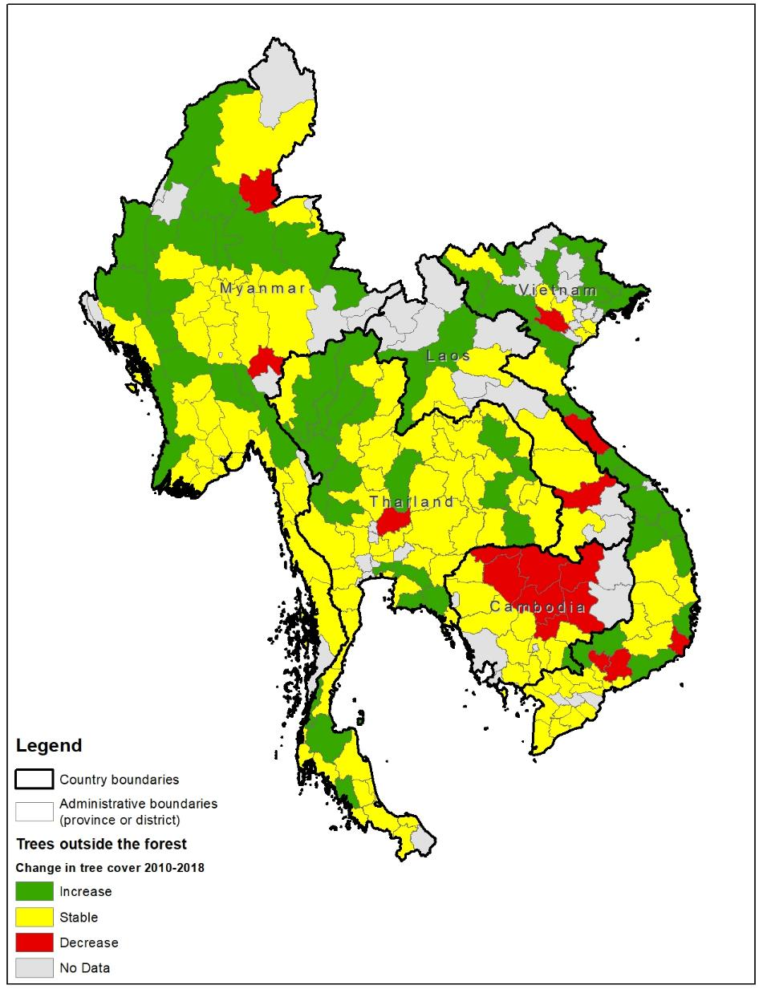

**Summary of results for Mekong region: Trees inside and outside the forest**

Given that forest landscape restoration includes interventions that increase tree cover both inside and outside of forest land uses, the results of the two separate analyses demonstrated the value in looking at both of these scenarios, given that trends are not always the same for each. The map in Figure 6 combines the information for trees inside the forest and trees outside the forest into one figure. In some areas, such as central Cambodia, there is a pattern of consistent decrease for both types of tree cover, and in parts of Thailand there is a consistent increase. However, throughout the rest of the region, the story is much more diverse and there are mixed results. For example, in Laos, there is widespread loss of trees inside the forest, but stability or increases in trees outside the forest. Throughout much of the region there is an opposite trend where trees outside the forest have increased, but trees inside the forest have increased (shown in dotted areas on the map). Both perspectives are important when considering the net impact of restoration on the landscape. In total, 62 subnational areas (provinces or districts) in the Mekong region out of 246 (25%) show signs of restoration progress, meaning that there is an increase in either trees inside or outside the forest, or stability in one type and increase in the other, while Thailand exhibiting the most widespread progress (Table 3).

Table 3. Provinces in the Mekong region with signs of restoration progress, by country

|  |  |  |  |
| --- | --- | --- | --- |
| **Country** | **No. provinces with signs of restoration progress** | **Total no. provinces** | **Percent of total** |
| Cambodia | 2 | 25 | 8% |
| Laos | 0 | 18 | 0% |
| Myanmar | 11 | 63 | 17% |
| Thailand | 38 | 77 | 49% |
| Vietnam | 11 | 63 | 17% |
| **Mekong region** | **62** | **246** | **25%** |

Figure 6. Change in tree cover inside and outside the forest by subnational jurisdiction.

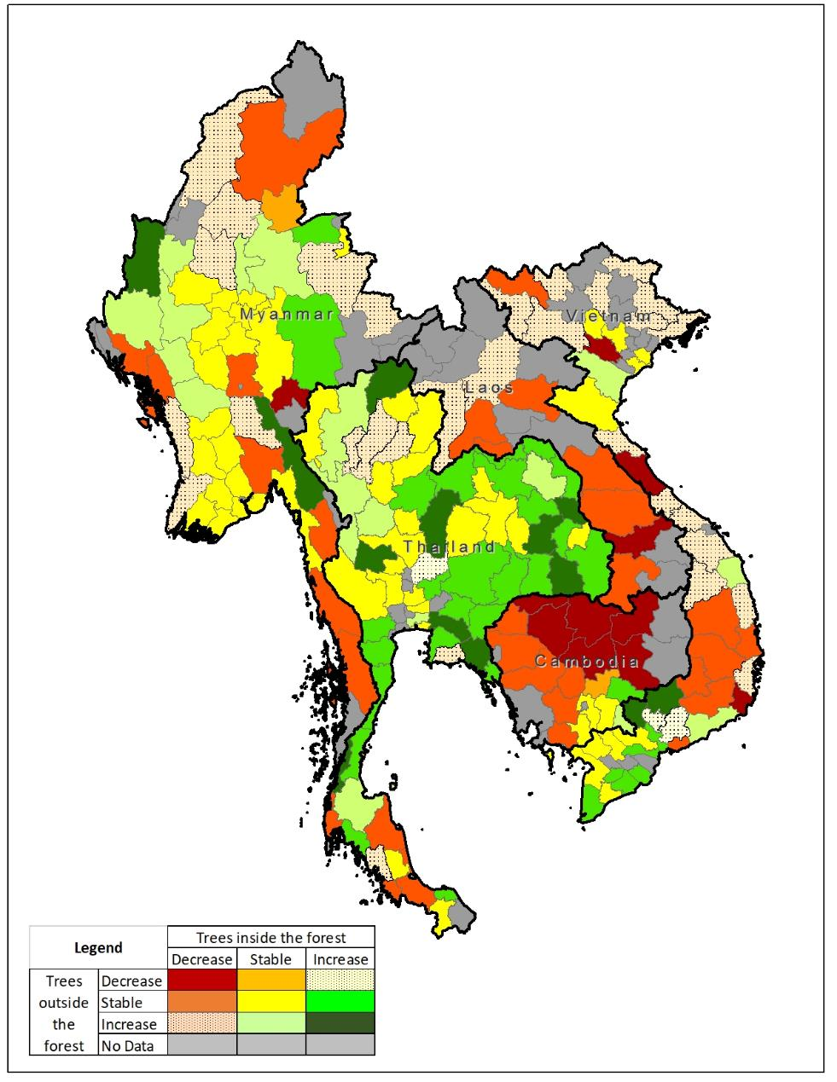

**Box 1: Case study of Vu Quang district, Vietnam**

Vu Quang is a district located on the western edge Han Tinh province along the border of Vietnam and Laos. It is characterized by steep, mountainous terrain and dense rainforest in the western part of the district. A detailed Collect Earth exercise was conducted for this district, where survey plots were distributed at 1 km intervals.

For survey plots where there was imagery available for both 2010 and 2018 (490 plots total), changes in land use and average tree cover could be calculated. Table 4 provides a summary of where changes in land use occurred, via a matrix that compares land use in 2010 (rows) to land use in 2018 (columns). While the majority of survey plots remained stable, most of the change that did occur was a shift from forest into other land use types, particularly cropland and wetland, which indicates a net loss in forest cover. For example, 23 sq km of land that was forest in 2010 was converted to cropland in 2018, and an additional 13 sq km and 12 sq km, respectively, was converted from forest to bushland/shrubland or grassland. However, in terms of restoration, there was also progress of note: a total of 14 sq km that was either cropland or grassland in 2010 became forest. The map in Figure 6 provides a visualization of this land use change matrix, showing which plots shifted from one land use to another. In the map, the encroachment of cropland, wetlands, and settlements from east to west into previously forested areas is evident.

Table 4. Matrix of land use change between 2010 and 2018.

|  |  |  |  |  |  |  |  |  |  |  |
| --- | --- | --- | --- | --- | --- | --- | --- | --- | --- | --- |
|  | **Land Use 2018 (sq km)** | | | | | | | |  | |
| **Land Use 2010 (sq km)** | **Barren** | **Bushland/ Shrubland** | **Crop-land** | **Forest** | **Grass-land** | **Other Land** | **Settle-ment** | **Wet-land** | | **Total (2010)** |
| Barren | 0 | 0 | 0 | 0 | 0 | 0 | 0 | 0 | | **0** |
| Bushland/ Shrubland | 0 | 4 | 4 | 0 | 2 | 0 | 1 | 1 | | **12** |
| Cropland | 0 | 0 | 49 | 7 | 2 | 0 | 1 | 2 | | **61** |
| Forest | 0 | 13 | 23 | 323 | 10 | 2 | 2 | 12 | | **385** |
| Grassland | 1 | 0 | 2 | 7 | 5 | 0 | 0 | 0 | | **15** |
| Other Land | 0 | 0 | 0 | 0 | 0 | 0 | 0 | 0 | | **0** |
| Settlement | 0 | 0 | 0 | 0 | 0 | 0 | 8 | 1 | | **9** |
| Wetland | 0 | 0 | 0 | 0 | 0 | 0 | 0 | 8 | | **8** |
| **Total (2017)** | **1** | **17** | **78** | **337** | **19** | **2** | **12** | **24** | |  |
| Change from 2010 to 2018 | 1 | 5 | 17 | -48 | 4 | 2 | 3 | 16 | |  |
| +100% | +42% | +28% | -12% | +27% | +200% | +33% | +200% | |  |

Figure 7. Change in land use type from 2010 to 2018 as evaluated in Collect Earth surveys.

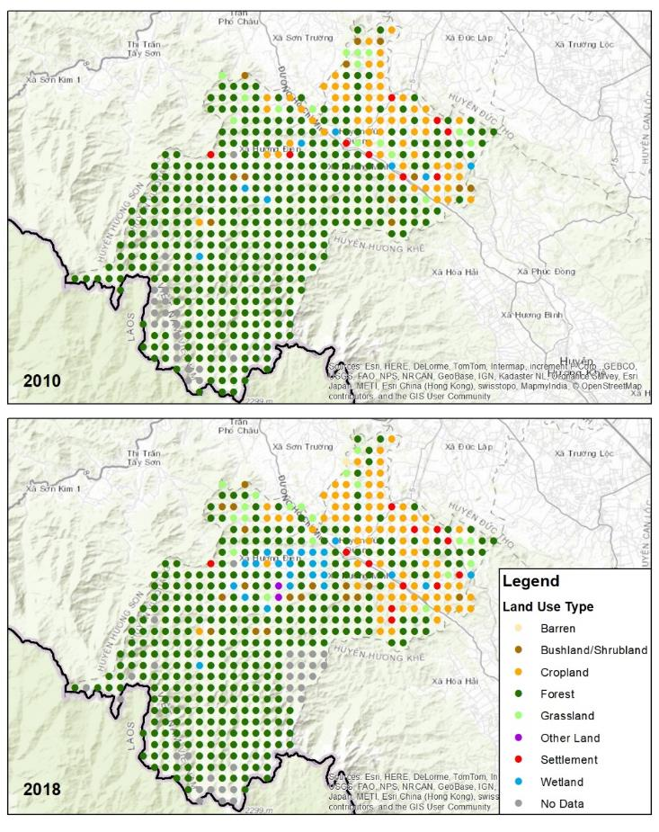

In terms of average tree cover, as shown in Figure 9, bushland/shrubland, cropland and wetlands all demonstrated increases in tree cover, which provides evidence of restoration of trees outside the forest. Settlements, grasslands, and forest indicated declines in tree cover, thus indicating increased degradation of these land use types. The Google Earth images in Figure 8 provide an example of a survey plot where tree cover increased from 2010 to 2018.

Figure 8. Google Earth images of a Collect Earth survey plot showing change in tree cover from 2010 (left) to 2018 (right).

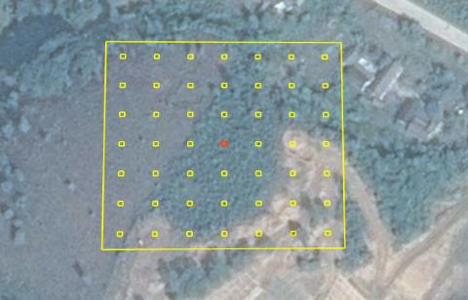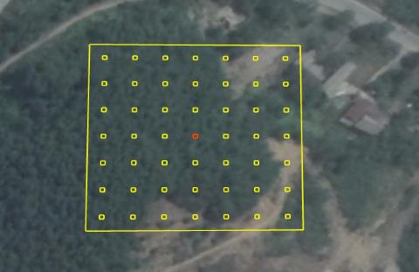

Figure 9. Average percent tree cover by land use type in 2010 and 2018

**2: On-Farm Tree Cover in Malawi**

In many parts of the developing world, restoration activities are focused on adding trees to mosaic landscapes, such as croplands and village lands, to leverage the benefits that trees provide to people and their livelihoods. In Malawi, a small land-locked country in southeastern Africa, the national government has developed a comprehensive National Forest Landscape Restoration Strategy that prioritizes tree-based restoration of agricultural landscapes. As a country that has a growing population, high incidence of poverty, and high dependence on subsistence farming, one of the main motivations for this restoration approach is to scale-up practices that increase productivity of cropland and reduce dependence on mineral fertilizers. One such approach is farmer-managed natural regeneration (FMNR), where the farmer selects and cultivates regenerating trees on his or her cropland at sparse intervals. The trees interspersed with crops stabilize the soils from erosion, and the fodder provides a natural source of fertilization. Over the past several decades, anecdotal evidence has shown that FMNR has increased in many parts of Malawi thanks to the efforts of local non-profit organizations, extension services, and peer-to-peer learning, but there have been limited studies that have quantified the extent of the practice.

One such tool that has been used to quantify the extent of on-farm tree cover is the Tree Cover Density Mapping Tool developed by the U.S. Geological Survey as an add-on to ArcGIS software. Similar to Collect Earth, it applies a grid-based sampling approach of tree density visible on high-resolution imagery (e.g., Google Earth) to count the number of the trees touching the calibrating grid for each sample plot. This visual-interpretation approach is best-suited to measure tree density outside of the forest, such as on cropland.

The Tree Density Mapping Tool was used to measure on-farm tree cover in two districts in the central region of Malawi: Dowa and Mchinji. The maps in Figure 10 show the percent of on-farm tree cover in 2009 (top) and 2017 (center), and the change in density between the two dates (bottom). The maps show that on-farm tree cover is widespread in the two districts and densities are quite high, particularly in Mchinji district. The map of change shows that, overall, there was widespread stability in tree density, with a slightly a higher incidence of increase than decrease in the two districts collectively. In Mchinji, there was much higher incidence of sample plots with increase, while in Dowa district, there were slightly more plots with a decrease. These results show that there are multiple methods and tools available to measure progress on restoration for trees outside the forest. In order to capture the full picture of restoration progress, it is important to include methods for measuring trees outside forests in the monitoring protocol.

Figure 10

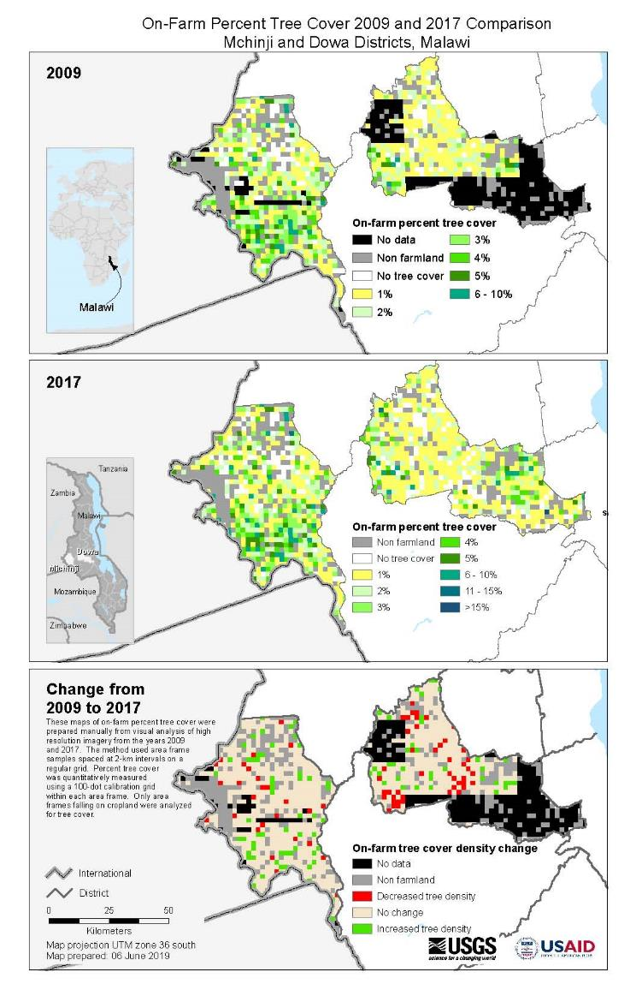

**Criterion 2: Forest landscape restoration efforts**

Having a shared understanding and a process for planning and prioritising restoration activities for given landscapes is essential to reach implementation and systematically track progress.[24] This shared understanding enables FLR to be implemented at different scales and according to varying national level priorities and landscape opportunities.

Bringing large tracts of degraded land into restoration to create diverse and lasting benefits often requires transformative processes including policy change and strengthening national implementation and monitoring capacities. We report on progress around this process of “bringing hectares into restoration” with findings on FLR commitments, uptake, and support. [25]

Indicator 2.1: High-level pledges

### Forest landscape restoration targets in the public sector

The public sector has put forth the majority of restoration pledges since the Bonn Challenge launched in 2011, and they are expected to continue to lead the process of planning to bring their pledges to implementation. As of April 2019, there were 58 Bonn Challenge pledges from countries, jurisdictions, and companies totaling 170.47 million hectares of restoration commitments for 2020 and 2030 combined.[26] Additionally, our analysis of FLR in NDCs has revealed the prevalence and importance of FLR activities in government plans to achieve climate mitigation and adaptation.[27] The analysis found that 127 of 165 NDCs, 77%, have quantitative and/or qualitative FLR-aligned targets. However, if qualitative targets are removed, only 49 NDCs (30%) have quantitative FLR-aligned targets for mitigation and/or adaptation.[28] The majority of quantitative targets in NDCs are expressed in hectares, and some provide targets in tCO2. There are approximately 57 million hectares and roughly 3.27 GtCO2 of FLR-aligned activities under NDCs’ un/conditional targets for the FLR-aligned activities. Our analysis shows that FLR is present in most NDCs, but the targets expressed represent only a portion of the global FLR opportunity, and if countries were able to better define, quantify, and finance their FLR activities then NDC ambitions could be increased to help move us toward the 1.5˚C degree pathway.

Another key aspect when considering public sector restoration targets is whether the country is committed to IP/LC tenure rights for natural resources. An analysis conducted by the Rights and Resources Initiative identified 24 countries that made a clear commitment to strengthen or expand indigenous people or local community tenure of natural resource management in the NDCs. Of these, half are in the context of restoration-oriented activities. In general, African countries were more likely to recognize a clear role for IP/LC tenure and management rights than other regions.

### Private sector commitments to support forest landscape restoration

As of x 2019, x companies had made [commitments to address deforestation](http://forestdeclaration.org/goal/goal-2/) in their supply chains. A smaller, but growing, number are also beginning to make pledges that include restoration activities. The nature of the pledges ranges from making explicit restoration commitments to embedding regenerative strategies into their business models, supply chains, or sustainability commitments. [“Net zero deforestation” commitments](http://forestdeclaration.org/goal/goal-2/) may also involve the use of reforestation as a means of offsetting deforestation taking place throughout supply chains.

We identified 16 major companies that include elements of forest landscape restoration in their plans to transition to sustainable supply chains.[29] Of these, only a third had explicit, quantified commitments (e.g. hectares, number of trees, or amount of money to be invested or donated) related to FLR activities. In most cases, these commitments were not overarching targets, rather pledges of support to individual FLR projects. An additional seven companies did not have specific commitments, but mentioned using FLR activities to implement their sustainability strategies. Two companies, Olam and Marks & Spencer, are currently assessing their sustainability frameworks and plan to share more concrete plans by 2020, which may include quantified FLR commitments.

The more common way companies (13 out of 16) engage with restoration is through a process known as “insetting” – the incorporation of sustainable forest management and zero deforestation in supply chains through certification schemes, stricter procurement codes, and due diligence. FLR activities in this category vary greatly, ranging from the planting of trees for raw materials to mosaic restoration on a landscape scale, demanding consideration of individual strategies and project design. Taylor Guitars, for example, has incorporated FLR into its sourcing of raw materials. Newly planted forests owned by the company are composed of both productive and native species. Michelin’s participates in insetting activities by sourcing from sustainable rubber plantations, but also provides financial (philanthropical) support to restoration projects from other organizations (see **Indicator 2.3**).

Indicator 2.2: Planning and implementation steps for restoring forests

##### Subheader

Global restoration requires a new level of planning through transformative processes including systematic site identification, enacting new policies, committing finance, and improving monitoring capacities. These success factors are now being measured and tracked in mutliple countries through the IUCN Bonn Challenge Barometer (**Box X**).

**5: Non-forest outcomes of FLR in Bonn Challenge countries**

Add on CO2 and social outcomes

Furthermore, identifying and developing appropriate activities for specific contexts are necessary conditions for meeting restoration goals. The planning and implementation process of FLR involves a number of steps that can provide insight on progress. Tools such as the Restoration Opportunities Assessment Methodology and The Restoration Diagnostic (**Box 4**) can help to facilitate and support these processes.

**Box 4: Planning tools for FLR**

The **Restoration Opportunities Assessment Methodology (ROAM)** was developed jointly by

IUCN and the World Resource Institute. The ROAM methodology serves as an assessment tool to

identifyrestoration potential and supports the development of restoration programmes as well as

landscapestrategies. At the stage of identifying and analysing areas applicable for FLR, ROAM

assists to definepriority areas and provides a shortlist of relevant and feasible restoration

intervention types. Inaddition, the tool provides information about finance and investment options for

restoration, estimatescarbon sequestered and breaks down costs and benefits for each intervention

type. Hence, the toolserves as a supporting framework throughout the project design and

implementation for restorationactivities.

**The Restoration Diagnostic** was developed as part of the ROAM. IUCN and WRI looked back on

historical landscape restoration to identify key success factors for FLR. The assessment tool

analyses conditions within landscapes and determines which factors for successful FLR are in place

and which ones are missing. The method supports stakeholders and decision makers in identifying

gaps and focusing their efforts on promising measures to maximize the success of FLR projects.

Add on CIFOR tools for FLR

##### Subheader

The Bonn Challenge is implemented through a number of approaches and mechanisms. These include national plans, which may be embedded in other initiatives. [Needs to be edited/added to]

More than 14.3 million hectares of conservation and restoration around the world are planned through the Green Climate Fund (GCF) and Global Environment Facility (GEF

[AFR 100 and Initiative 20 x 20 description to be added]

##### Subheader

Since 2017, the IUCN-administered Bonn Challenge Barometer has worked with government officials and implementing agencies in various countries to define parameters of FLR success, identify appropriate progress indicators, and develop appropriate reporting structures with quality control measures. The information for the Barometer is self reported by countries to the secretariat of the Bonn Challenge, IUCN, adhering to the systematic database and guidelines found in the Barometer Protocol. In some cases, data collection was also conducted by IUCN staff and consultants. A total of 19 countries out of 51 Bonn Challenge pledges provided data to IUCN in 2018, the first year of application of the Barometer. Detailed information, however, currently remains limited to six countries. In this section, we highlight developments from four of those countries – the United States, Brazil, Rwanda, and El Salvador.

In the United States, the implementation of FLR activities was achieved through policy changes that provided guidance for restoration and joint implementation efforts within Federal Agencies responsible for federal land management. Much of the restoration undertaken in the US was to resolve forest management issues concerning fire and pests and to restore and protect watersheds, and these commercial, safety, and water security issues helped the US justify its 8 billion USD public-spending on restoration. The USA’s Bonn Challenge commitment was made possible by the USFS’s dedication to FLR and supported and realized by a broad base consisting of multiple NGOs as well as private and public organisations. The official Forest Service Manual “Chapter 2020: Ecosystem Restoration” and the Agricultural Act of 2014 sustain the USFS’s progress towards it’s restoration targets.

In the tropics, Brazil reported large areas of regeneration, established through improved land governance that allowed coordination and implementation of restoration efforts across public and private sectors.[30] Contributions to the Bonn Challenge serve two vegetation-recovery related targets of the Brazilian governmnet: NDC and PROVEG. Several policies and instruments support FLR approcaches such as the National Policy on Climate Change, the Native Vegetation Protection law as well as the National Conservation Areas System and National Biodiversity Strategy. These policy developments are accompanied by community engagement of a strong social and environmental movement inclunding the Brazilian Coalition on Climate, Forests and and Agriculture as well as PACTO. The government’s planning for restoration included both ecological and financial criteria to select priority areas, and Brazil used ROAM and remote sensing to map and estimate the restoration potential across their landscapes. These planning efforts were bolstered by cross-ministry coordination in policy design and implementation. The government also provided support to private landowners to meet their legal requirements under national forest policy, which in turn enabled restoration on additional lands. The sustainability of these efforts is uncertain in the light of the change in government in Brazil and the policy priorities of the new government.[31]

Similarly, Rwanda has incorporated forest restoration into its sustainable development agenda, and critical to its success thus far is the strong policy framework that encompasses the multitude of FLR-aligned policies enacted in 2018. Further strengthening, especially of forest and environment related policies, as a response to new conventions by the government and prevailing concerns such as climate change point to the importance of a low-carbon development approach to the country. The planning in Rwanda began with ROAM in 2014 and the results identified agroforestry and other restoration types as priorities, which led to the adoption of an Agroforestry Strategy and Action Plan for 2018-2027, among other long-term policies, demonstrating the country’s commitment through committed public expenditures and attracting international donor support.

In central America, El Salvador set an example with the El Salvador’s National Ecosystem and Landscape Restoration Program (PREP) developed and facilitated by the Ministry of Environment and Natural Resources (MARN) in 2013. PREP has evolved into an operational action plan and includes a monitoring system with a main FLR activity database. Building on PREP, MARN implemented ROAM in cooperation with IUCN and other national parties in 2016 and 2017. As a result the national restoration action plan and strategy for 2018-22 was tightened and MARN pledged to take responsibility for the restoration of 400,000 ha. PREP is complemented by the National Forest Policy with sustainable water and soil management goals as well as a series of actions to restore ecosystems and increase forest cover, led by the Ministry of Agriculture and Livestock (MAG). A high range of restoration interventions have been applied, but are dominated by agroforestry and silviculture.

Despite the differences between these national contexts, according to the reporting from all Barometer pilot countries common success factors include technical planning that incorporated a multidisciplinary approach, and intersectoral coordination in implementation, and directing financial flows to restoration activities.[32]

Indicator 2.3: Finance for forest landscape restoration activities

The availability and access to finance is essential to the achievement of FLR commitments (**Box 6**). So far, nearly x USD has been committed from various public and private sources.

**Box 6: Financing needs for forest landscape restoration**

If FLR activities are to be scaled up to meet global goals, the expected costs of FLR projects must be clearly communicated to investors, donors, and other financiers. According to estimates produced by The Economics of Ecosystems and Biodiversity (TEEB), global cost-per-hectare estimate of FLR range from USD 2,390 to USD 3,450 (**Table 5**).[33]

Table 5

|  |  |  |  |  |
| --- | --- | --- | --- | --- |
| Initiative/target | Land area (million ha) | Time frame | Estimated budget required (billion USD) | |
| Total | Annual |
| Bonn Challenge | 150 | 2011-2020 | 359 - 518 | 36 - 52 |
| NYDF | 350 | 2014-2030 | 837 – 1,208 | 49 - 71 |

*Source: Own Adaptation of FAO and Global Mechanism of the UNCCD, 2015 following TEEB, 2009b*

The cost estimates were derived from 95 peer-reviewed studies on FLR projects and consider factors such as the forest biome.[34] Opportunity costs of forgoing alternate land uses are not included within these cost estimates. Additionally, the costs of individual projects will vary from site to site according to degree of degradation and specific social, political, and biophysical characteristics and circumstances. Another limitation to estimating the financial need for FLR activities is the lack of detailed reporting of observed costs in academic literature. A larger body of reliable cost reporting is needed for more accurate global estimates of the cost of FLR projects.[35]

According to the Bonn Challenge Barometer, USD 9.5 billion has been commited for FLR activities in the United States, and a cumulative of USD 1 billion in Brazil, El Salvador, Mexico, and Rwanda.[36] While all the finance in the United States comes from domestic sources, the finance in the other countries consists of domestic public expenditures and philanthropic and non-profit contributions, international donor support, and private investment (**Box 7**).

**Box 7: Private sector support for FLR**

Of the sustainability strategies of 16 companies assessed (see **Indicator 2.1**) involved some degree of outsourcing or philanthropic support for the FLR activities of partner organizations such as NGOs. This is likely because these organizations have the local networks and expertise needed to design and implement meaningful and successful FLR projects. More to be added.

In some countries, National Forest Funds (NFFs) are used to directly finance FLR projects. They can relieve financial and social barriers for rural communities, SMEs, and smallholders when trying to secure financing from other sources while promoting FLR projects on the ground. Their position allows them to draw financing from multiple sources while encouraging private investment. Domestic sources include general and special taxes, international sources can be bilateral and multilateral DFIs, as well as global climate funds participating in REDD+ funding and payment schemes.

Costa Rica’s National Forestry Finance Fund (FONAFIFO), one of the first of its kind, takes on a more decentralized structure. It operates as a trust fund independently administered by an appointed governing board that transfers ownership and rights of projects to trustees. FONAFIFO’s primary source of funding is a special fuel tax, and other sources include the GEF and PES contributions from hydropower companies. The Fund disperses financial services through intermediary NGOs like Fundación para el Desarrollo de la Cordillera Volcánica Central (FUNDECOR), who provide technical support to improve the impact of financing. The monitoring, reporting and verification is then outsourced to the private sector.[37]

The National Climate and Environment Fund of Rwanda (FONERWA), takes on a more centralized structure of national forest funds. The Government of Rwanda consolidated their pre-existing institutional infrastructure with FONERWA absorbing the forest fund and instead operates with one funding window alongside other climate windows. The Fund’s capital sources include environmental fines and fees, forestry and water funds, seed financing from stakeholders, and inspection fees. Funds are dispersed through two primary channels. The public sector goes through the Environmental Management Authority, and the private sector receives funds from the Rwanda Development Bank.[38]

To be added: finance committed through the GCF and GEF for activities with an FLR contribution

Additionally, innovative financing platforms such as the Tropical Finance Facility use a combination of public grants along with concessional and non-concessional loans to unlock private finance in forests, land use, agriculture and other areas. The platform itself is managed by ADM Capital, and the long-term debt products are arranged by BNP Paribas.[39] The facility’s first transaction was a USD 95 million sustainability bond to provide initial finance for a project developing a sustainable natural rubber plantation while conducting FLR activities on heavily degraded land. The plantation areas are designed to serve as a buffer zone to protect the Bukit Tiga Puluh national park from further encroachment and degradation.[40]

1. Convention on Biological Diversity. (2019, June 10). Retrieved from: <https://www.cbd.int/reports/>
2. Santurf, Lamb and Madsen (eds). 2012. Forest Landscape Restoration Integrating Natural and Social Sciences
3. IISD 2002, Laestadius et al. 2015, Mansourian et al. 2005, Maginnis and Jackson 2007, Sabogal et al. 2015
4. Stanturf, John; Mansourian, Stephanie; Kleine, Michael; eds. 2017. Implementing Forest Landscape Restoration, A Practitioner‘s Guide. International Union of Forest Research Organizations, Special Programme for Development of Capacities (IUFRO-SPDC). Vienna, Austria.
5. Chazdon et al. 2019. Co-creating Conceptual and Working Forest and Landscape Restoration Frameworks Based on Core Principles. A white paper for the Forest and Landscape Restoration Standards Taskforce (FLoRES)
6. Besseau et al. 2018, p. 18 // Add principles of FLR.
7. UNFCCC. (2002). Marrakesh Accords. Retrieved from: https://unfccc.int/resource/docs/cop7/13a01.pdf
8. The Global Partnership on Forest and Landscape Restoratation/ Bonn Challenge
9. The Global Partnership on Forest and Landscape Restoratation/ Bonn Challenge
10. Cook-Patton et al. 2019 (in review). The potential for natural reforestation to mitigate climate change.

    *The taxonomy and definitions of the forest landscape restoration activities were developed through an expert workshop with 25+ scientists at the University of Oxford in the fall of 2018.
11. UNFCCC. (2002). Marrakesh Accords. Retrieved from https://unfccc.int/resource/docs/cop7/13a01.pdf
12. Ibid.
13. Dave 2018, Dave 2019 – add references
14. Robin L. Chazdon, et al. (2008). Beyond Deforestation: Restoring Forests and Ecosystem Services on Degraded Lands. Science 320, 1458. <https://science.sciencemag.org/content/320/5882/1458>
15.
16. IUCN (2018). Bonn Challenge Barometer – Progress Tracking Protocol. <https://infoflr.org/bonn-challenge-barometer>
17. Additional methods for literature review: Systematic review of primary literature using the Web of Science (Core Collection; Thomson Reuters, New York, New York, USA) database. We searched peer-reviewed literature in the Web of Science database from 2010 to 2019 using the search terms “monitor* OR progress* OR success* OR status AND forest* OR landscape* OR peatland* OR mangrove* OR agroforest* OR plantation* AND restor* OR regenerat* OR afforest* OR reforest* AND *forest* AND area* OR hectare* OR kilom*”. These search terms were chosen to target forest cover increase while excluding methods-centered work. These criteria netted an initial 3,654 papers for further consideration.
18. Dave, R., Saint-Laurent, C., Murray, L., Antunes Daldegan, G., Brouwer, R., de Mattos Scaramuzza, C.A., Raes, L., Simonit, S., Catapan, M., García Contreras, G., Ndoli, A., Karangwa, C., Perera, N., Hingorani, S. and Pearson, T. (2019). Second Bonn Challenge progress report. Application of the Barometer in 2018. Gland, Switzerland: IUCN. xii + 80pp.
19. Romijn, J.E.; Coppus, R., 2019, "Replication Data for: Restoration Database for Latin America and the Caribbean. Comparative Research Project on Landscape Restoration for Emissions Reductions, CIAT/WUR project for USAID", <https://doi.org/10.7910/DVN/B9OUOZ>
20. GEF Forest and Landscape Restoration. Website accessed 06/2019: <https://www.thegef.org/topics/forest-and-landscape-restoration>
21. Bastin et al., *Science* 356, 635–638 (2017).
22. FAO, 2015. Global Forest Resources Assessment 2015. FAO Forestry Paper No.1. The Food and Agricultural Organization of the United Nations (FAO). Rome.
23. Ideally, the analysis would specifically report progress since the launch of the NYDF in late 2014. However, the lack of data past 2017 was a limiting factor. We determined that the time period for 2015-2017 was too short to provide meaningful results on restoration progress.
24. <https://www.srs.fs.usda.gov/pubs/books/2017/book_2017_stanturf_001.pdf>
25. Bonn Challenge Progress Report. (2018). *Application of the Barometer in 19 Bonn Challenge pledging entities.*
26. <http://www.bonnchallenge.org/>
27. IUCN and Climate Focus (2018). FLR in NDCs analysis. <https://infoflr.org/what-flr/increasing-ambition-and-action-ndcs-through-flr>
28. IUCN and Climate Focus. (2018). FLR in NDC analysis. Publication forthcoming.
29. Companies for analysis were selected based on consultation with experts and desk research.
30. IUCN. (Forthcoming). *Bonn Challenge Progress Report, 2018: Application of the Barometer in 19 Bonn Challenge pledging entities*.
31. Dismantling of Brazilian environmental protections gains pace. (2019, May 8). *Mongabay Environmental News*. Retrieved May 21, 2019, from https://news.mongabay.com/2019/05/dismantling-of-brazilian-environmental-protections-gains-pace/.
32. IUCN. (Forthcoming).
33. FAO and Global Mechanism of the UNCCD. (2015). *Sustainable financing for forest and landscape restoration: Opportunities, challenges, and the way forward*.
34. TEEB. (2009b). *Climate Issues Update September 2009*.
35. TEEB. (2009a). Chapter 9 Investing in ecological infrastructure. In *The economics of ecosystems and biodiversity for national and international policy makers*.
36. Bonn Challenge Progress Report. (2018). *Application of the Barometer in 19 Bonn Challenge pledging entities.*
37. Matta, R. (2015). *Towards effective national forest funds*. In *FAO Forestry Paper*: *Vol.* *174*. ;
38. FONERWA. (2012). *Final Report. Government of Rwanda Environment and Climate Change Fund (FONERWA) Design Project.*
39. Tropical Landscape Finance Facility. (n.d.-b). Lending Platform. *Tropical Landscapes Finance Facility*. Retrieved April 5, 2019, from http://tlffindonesia.org/lending-platform/.
40. Mulder, I. (2018). World’s first ‘sustainable landscape bond’ supports Indonesia’s economic development. *UN-REDD Programme*. Retrieved April 5, 2019, from https://www.un-redd.org/single-post/2018/03/01/World%E2%80%99s-first-%E2%80%98sustainable-landscape-bond%E2%80%99-supports-Indonesia%E2%80%99s-economic-development.